AS3959

Obtaining a developed wind flow

* The distance between the inlet and the starting of forest = 120 m
* Set up velocity device at every 10 m interval.
* Inlet wind velocity: SEM method

Two grid sizes were considered at the open wind land area

1. 0.75 m 🞨 0.75 m 🞨0.75 m – 40 seconds completed in simulation within 108 hrs
2. 0.75 m 🞨 0.75 m 🞨1.5 m – 118 seconds completed in simulation within 105 hrs

|  |
| --- |
|  |
| |  | | --- | | 1. 1.5 m 🞨 1.5 m 🞨1.5 m after 40 s of running. Previous CSV files used to initiate the flow. | |

**around X=-105m and 10 m height U=19.4563 m/s. Requirement is 19.44 m/s.**

\*\***Get 19.44 m/s at around x-50 m**

Douglas fir tree burning

Examined **NU_MATL** and **NU_SPEC**

1. Grid 50 mm +Haider Drag model + (NU_MATL = **0.69**, NU_SPEC = **0.31**)

|  |
| --- |
|  |

Total mass loss difference between the experiment and the simulation = +8.5%.

1. Grid 50 mm +Haider Drag model + (NU_MATL = **0.61**, NU_SPEC = **0.39**)

|  |
| --- |
|  |

Total mass loss difference between the experiment and the simulation = -7.1%

AS3959 Firebrand generation source term calculation based on the **species, FMC,** and **wind velocity**

1. Species

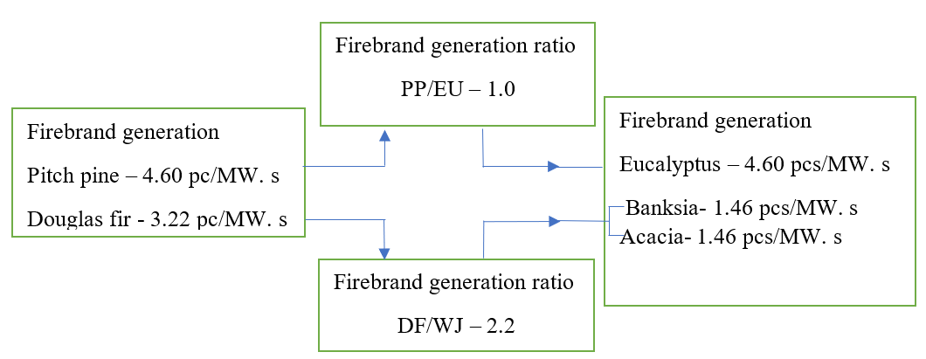

PP-pitch pine

DF-Douglas fir

WJ-Western Juniper

1. FMC

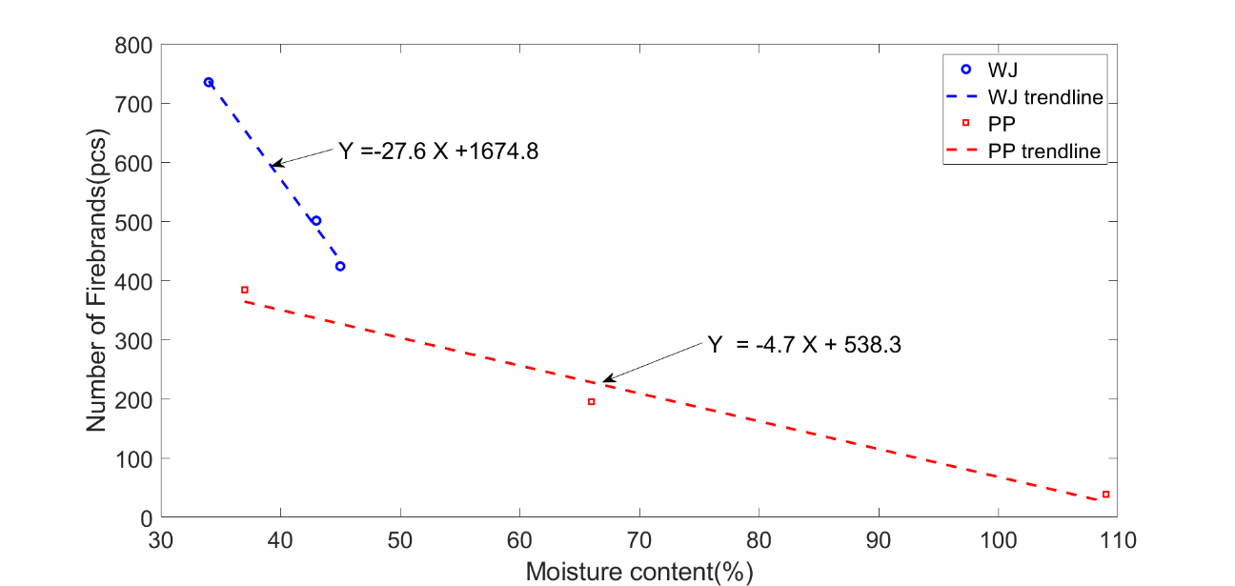

The number of firebrands generated varying the fuel moisture content (FMC) of Western Juniper (WJ) and Ponderosa Pine (PP). Increasing MC results decreasing in firebrand generation. The trend is linear, and it is given the equation of each trendline to find the number of firebrand generation at certain FMC.

|  |  |  |  |  |  |
| --- | --- | --- | --- | --- | --- |
| Vegetations | Firebrand generation rate  (pcs/MW.s) | MC (%) | Number of firebrands | Generation ratio to  3.22% MC | Generation rate (pcs/MW.s) |
| Western Juniper  Douglas fir  Banksia/Acacia | 3.22  (Douglas fir ) | 3.84 | 1569 | (1569/1398)=1.00 | 3.22🞨1.00=3.61 |
| 10 | 1398 | (1398/1398)=1.00 | 3.22🞨1.12=3.22 |
| Ponderosa pine  Pitch pine  Eucalyptus | 4.60  (Pitch pine) | 3.84 | 520 | (520/392)=1.00 | 4.60🞨1.00=6.10 |
| 31 | 392 | (392/392)=1.00 | 4.60🞨1.33=4.60 |

1. Wind effect

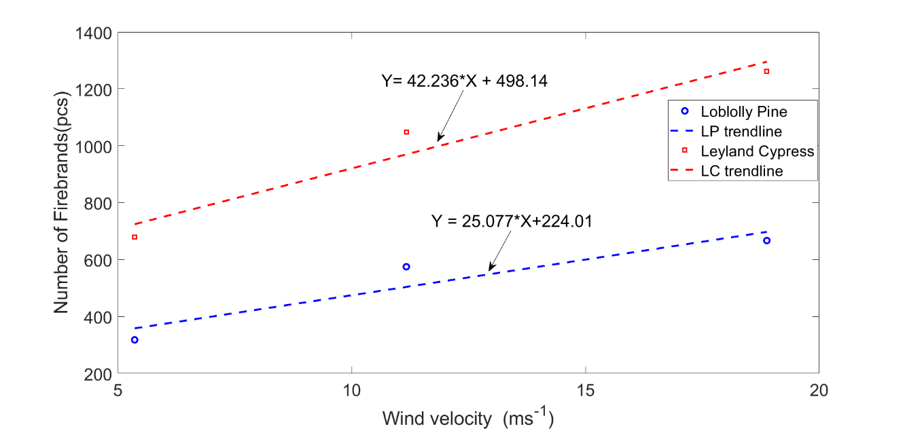

The experimental results of the number of firebrands collected in Idle, medium, and High wind speeds for Loblolly pine and Leyland cypress vegetations. Increasing wind speeds shows an increment of firebrands collection. The experiment was set up to collect all the firebrands generated in each tree burning of Bahrani et al.

|  |  |  |  |  |  |
| --- | --- | --- | --- | --- | --- |
| Vegetations | Firebrand generation rate  (pcs/MW.s) | Wind (m/s) | Number of firebrands | Generation ratio to  2 m/s and 0 m/s | Generation rate (pcs/MW.s) |
| Loblolly pine  Pitch pine  Eucalyptus | 4.60  (Pitch pine at  2 m/s) | 2 | 274 | (274/274)=1.00 | 4.60🞨1.00=4.60 |
| 11.11 | 503 | (503/274)=1.84 | 4.60🞨1.84=8.46 |
| 16.67 | 642 | (642/274)=2.34 | 4.60🞨2.34=10.76 |
| 19.44 | 712 | (712/274)=2.60 | 4.60🞨2.60=11.96 |
| Leyland Cypress  Douglas fir  Banksia/Acacia | 3.22  (Douglas fir  at 0 m/s) | 0 | 498 | (498/498)=1.00 | 3.22🞨1.00=3.22 |
| 11.11 | 967 | (967/498)=1.94 | 3.22🞨1.94=6.25 |
| 16.67 | 1202 | (1202/498)=2.41 | 3.22🞨2.41=7.77 |
| 19.44 | 1319 | (1319/498)=2.65 | 3.22🞨2.65=8.53 |